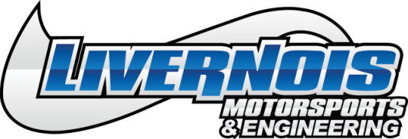
FOR IMMEDIATE RELEASE:
Livernois Motorsports & Engineering Announces Windstorm Cold Air Intake Kit for 2018-2019 Jeep Grand Cherokee Trackhawk
Dearborn Heights, MI (October 2018) – Livernois Motorsports has announced an expansion of its Windstorm product line of cold air intake kits to include 2018-2019 Jeep Grand Cherokee Trackhawk models. Designed to be used as a stand-alone upgrade or as an addition to any Livernois Motorsports Powerstorm packages, the new Windstorm cold Air intake will provide additional horsepower, torque, and improved sound in the Jeep Grand Cherokee Trackhawk.
Each Windstorm cold air intake for the Jeep Grand Cherokee Trackhawk features a 5" diameter mandrel bent intake tube with 6" inlet and dry-flow filter element which provides massive flow with a smooth path for air to travel. This intake system has been tested to more than 1250 horsepower, proving to have substantial increases in airflow over the stock, restrictive air box and tube design. All necessary hardware is included, which allows installation to be done quickly and easily with simple hand tools, while its durable powder coating, and stainless hardware ensure great looks for years to come.
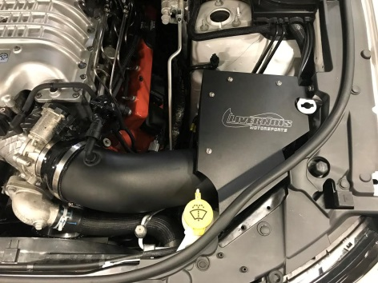
The Windstorm Jeep Grand Cherokee Trackhawk Cold Air Intake retails at $459.99 and is available for purchase online at www.livernoismotorsports.com , by phone at 313.561.5500 or at the Livernois Motorsports Dearborn Heights location.

Livernois Motorsports & Engineering Windstorm Cold Air Intake Kit for Jeep Grand Cherokee Trackhawk: P/N #LPP420001
About Livernois Motorsports & Engineering
Livernois Motorsports & Engineering has become best-known for revolutionary tuning and high-end performance products for late model Ford, Mopar and GM vehicles. The company is proud of its deep roots in the automotive and motorsports industry dating back to its original founding in 1949. Since then the company has expanded its product line to include tuning and performance components for desert racing, SCCA and drag racing. Livernois Motorsports is proud to engineer, test and manufacture its products in the USA. For more information visit www.livernoismotorsports.com or call 313.561.5500.

Media Contact
Kevin Cassar: (Corporate Marketing & Events Coordinator) (313)-561-5500 Ext 107, kcassar@livernoismotorsports.com

###
2500 S Gulley Rd. • Dearborn Heights, MI 48125 • www.livernoismotorsports.com • 313.561.5500

