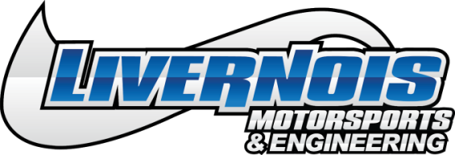
FOR IMMEDIATE RELEASE:
Livernois Motorsports & Engineering Announces 2018-2019 Chrysler Gateway Module Bypass Cable
Dearborn Heights, MI (October 2018) – Livernois Motorsports is proud to announce the release of their Gateway Module Bypass Cable for 2018-2019 Chrysler, Dodge, Jeep, and Ram vehicles. This cable allows you to use aftermarket programming and diagnostic tools for reading, programming, datalogging, and other service-related items on these vehicles.
This cable was designed to ensure a clean, quick, and simple installation with no cutting or splicing required. It also prevents sometimes lengthy and complicated disassembly required to gain access to the gateway module in the vehicle while utilizing OEM quality connectors and construction.
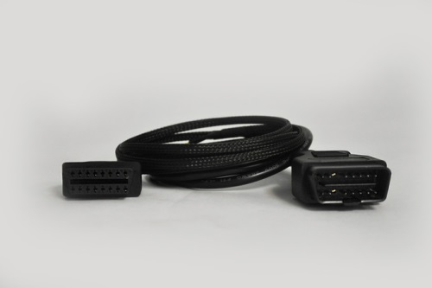

Livernois Motorsports & Engineering MyCalbirator Programming Cable For 2018 & 2019 Chrylser, P/N #LPP621000

About Livernois Motorsports & Engineering
Livernois Motorsports & Engineering has become best-known for revolutionary tuning and high-end performance products for late model Ford, Mopar and GM vehicles. The company is proud of its deep roots in the automotive and motorsports industry dating back to its original founding in 1949. Since then the company has expanded its product line to include tuning and performance components for desert racing, SCCA and drag racing. Livernois Motorsports is proud to engineer, test and manufacture its products in the USA. For more information visit www.livernoismotorsports.com or call 313.561.5500.

Media Contact
Kevin Cassar: (Corporate Marketing & Events Coordinator) (313)-561-5500 Ext 107, kcassar@livernoismotorsports.com

###
2500 S Gulley Rd. • Dearborn Heights, MI 48125 • www.livernoismotorsports.com • 313.561.5500

