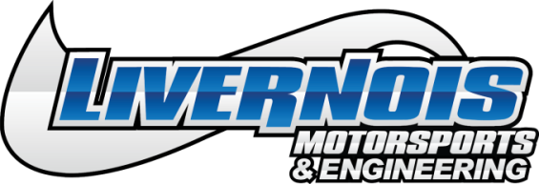
FOR IMMEDIATE RELEASE:
Livernois Motorsports & Engineering Announces Powerstorm Forged Pistons for the 2018 Ford Mustang GT Coyote 5.0L Engine
Dearborn Heights, MI (October 2018) – Livernois Motorsports & Engineering is pleased to announce that the Powerstorm line of products now includes forged pistons for the 2018 Ford Mustang GT Coyote 5.0L engine, available in 11:1 and 12:1 compression ratios. Engineered for use in applications with up to 1400 horsepower.
Powerstorm pistons for the 2018 Ford Mustang GT are a product of years of research and testing, and offer the latest in design advances and features. Made for naturally aspirated and forced-induction applications, the complete set of Powerstorm pistons are made from 2618 material and utilize a custom-forging design. The set also includes .200 wall pins and a stainless-steel ring set to compliment the pistons.
Every Powerstorm piston is designed at the Livernois Motorsports & Engineering facility in Dearborn Heights, MI, and manufactured in the USA.
The Powerstorm Pistons for the 2018 Ford Mustang GT Coyote 5.0L Engine retail at $999.99 and are available for purchase online at www.livernoismotorsports.com, by phone at 313.561.5500 or at the Livernois Motorsports & Engineering Dearborn Heights location.
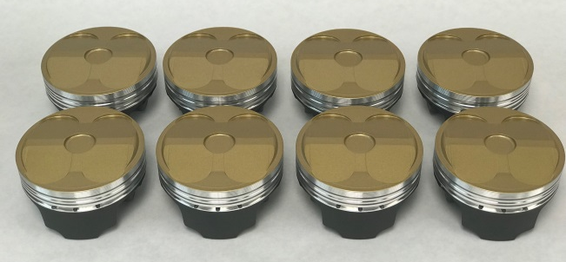

Livernois Motorsports & Engineering Powerstorm Pistons for 2018 Ford Mustang GT Coyote 5.0L Engine; PN #RRP302LM & RRP303LM
About Livernois Motorsports & Engineering
Livernois Motorsports & Engineering has become best-known for revolutionary tuning and high-end performance products for late model Ford, Mopar and GM vehicles. The company is proud of its deep roots in the automotive and motorsports industry dating back to its original founding in 1949. Since then the company has expanded its product line to include tuning and performance components for desert racing, SCCA and drag racing. Livernois Motorsports is proud to engineer, test and manufacture its products in the USA. For more information visit www.livernoismotorsports.com or call 313.561.5500.

Media Contact
Kevin Cassar: (Corporate Marketing & Events Coordinator) (313)-561-5500 Ext 107, kcassar@livernoismotorsports.com
###
2500 S Gulley Rd. • Dearborn Heights, MI 48125 • www.livernoismotorsports.com • 313.561.5500

